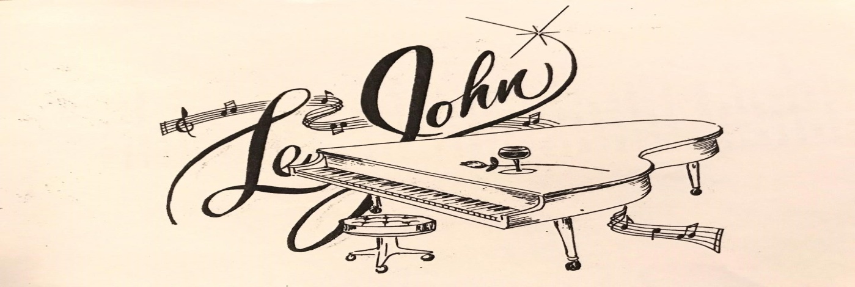

**MY HEART AND SOUL, TO YOURS**

LeJohn, is a soulful dynamic vocalist, songwriter, musician and command the stage entertainer.

He has the smooth sounds of R&B and Easy Listening, for those music lovers wanting to hear old and new school deliverances of love in melodies with poetic and inspirational songs, that many ballad music lovers would call it; “Baby making music”.

He has been in the music business for years, beginning in elementary school, onto his teenage years as a member of several musical groups in the Mid-West, until he decided to be a solo performer and songwriter, and eventually recording and releasing songs that charted the top one hundred list of music on the airwaves and as an opening act or stage guest for other established entertainers, throughout his musical journey.

LeJohn, says his vocal style of singing and songwriting, comes from his lifelong admirations and studying of musical Legends; Smokey Robinson, Stylistics, Delfonics, Moments aka Ray, Goodman & Brown, and his hometown Chicago’s “Chi-Lites and other great performers and songwriters.

As he described his logo; “A rose for the ladies, toast from the glass to the guys, and with music from LeJohn for everyone”.

New songs to be released in 2019.